Course: COSC457.101 – Database Management Systems

Instructor: Leon Bernard

Room: YR-304

February 20, 2020 8:00 pm

**Database Model**

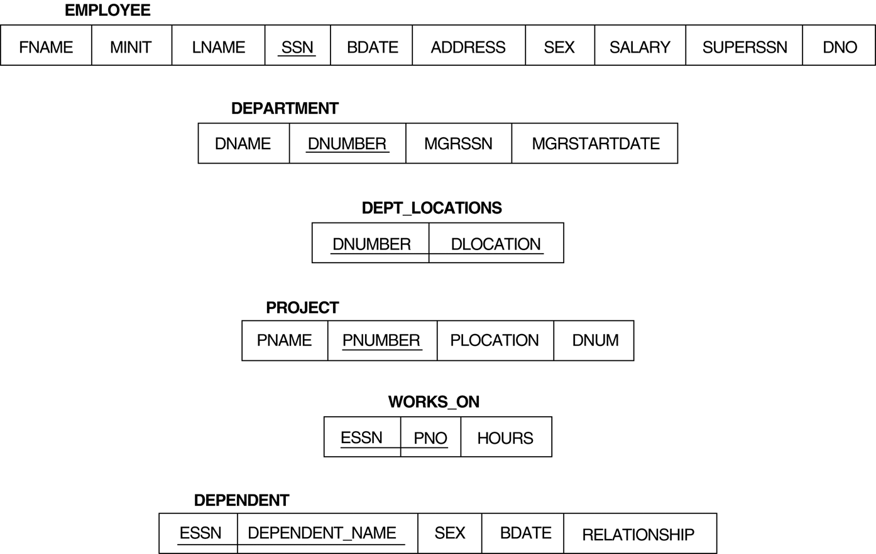

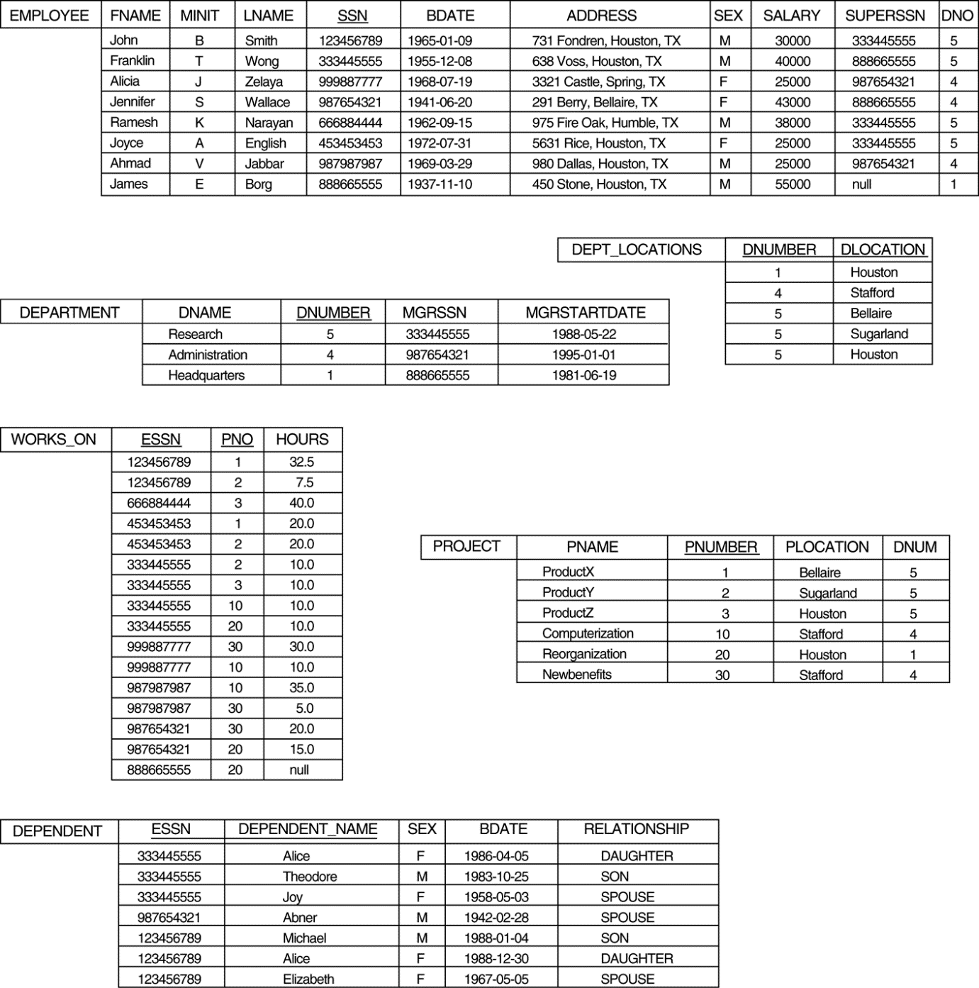

**SQL statements**

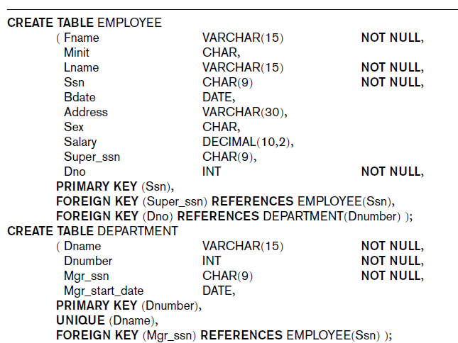

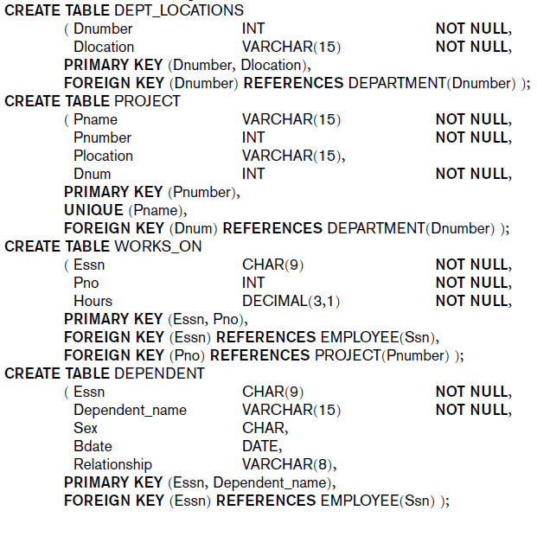

**Questions**

1. Create EMPLOYEE Table
2. Create DEPARTMENT Table
3. Create DEPT_LOCATIONs table
4. Find the names of employees that are directly supervised by ‘Franklin Wong’.
5. For **each** department, retrieve the department name, and the average salary of employees working in that department.